EXPANDED VERMONT WIC FOOD OPTIONS DURING COVID-19
The COVID-19 pandemic has made it harder to find some items in the grocery store, including some WIC foods. To help families during this time, Vermont WIC is temporarily expanding WIC-approved foods in the following categories:

Whole Grains  More whole wheat and whole grain bread options in sizes up to 24 oz*  New 16 oz oatmeal option as a whole grain*  *See Whole Grain Section for images and brands | Eggs  WIC-approved eggs now include Extra-large and Jumbo sizes and enhanced eggs.  Any brand  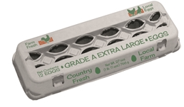  No Organic | Milk  2% milk is now WIC-approved for women and children 2-5 years old who have 1% or skim on their food package.  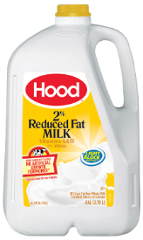  Any brand
Cheese  WIC-approved cheese now includes 8 oz and 16 oz package size shredded Mozzarella, Cheddar, Monterey Jack, Colby and Muenster cheese in previously approved brands.  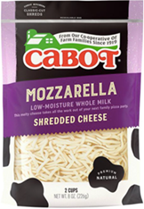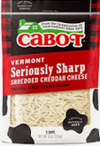 | Breakfast Cereal  New cereals  Kellogg's Special K  - Banana  Frosted Mini-Wheats  - Blueberry  - Strawberry  Quaker’s Oatmeal Squares  - Honey Nut  Life  - Vanilla  - Strawberry  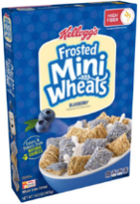  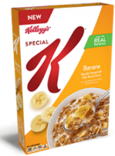  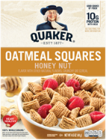  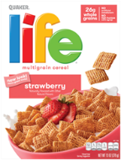 | Juice  WIC-approved juice now includes shelf stable organic juices and frozen store brand apple and grape 11.5oz—12oz cans  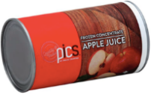
Infant Foods
WIC-approved infant foods now include Nature’s Heart 4oz Organic Infant Fruits

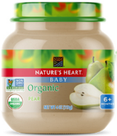
Tofu
WIC-approved tofu now includes 16oz Heiwa organic tofu
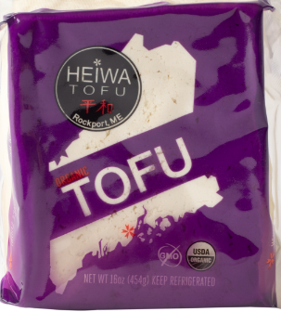

In the store and not sure if it’s a new WIC-approved food? Try the WIC Shopper App to scan the bar code, then compare to YOUR family food benefit list to double check.

*Whole Grain Options

Oatmeal - 16 oz size
16 oz Oatmeal counts as a Whole Grain Option (not Breakfast Cereal)
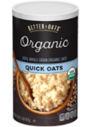  Better Oats  Organic Quick Oats  UPC: 042400197553  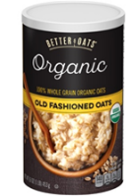  Old Fashioned Oats  UPC: 042400197560 | 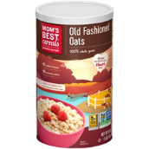  Mom's Best  Old Fashioned Oats  UPC: 883978152854  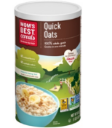  Quick Oats  UPC: 042400016922 |  | 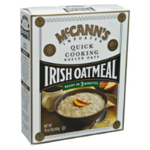  McCann's Irish  Quick Cooking  UPC: 072463000217  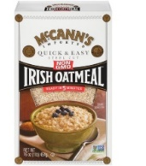  Steel Cut  UPC: 072463000309
Bread
Temporary Size Options During COVID 19:
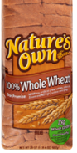  Nature’s Own  100% Whole Wheat  Size: 20 oz  UPC: 072250037129  100% Whole Wheat  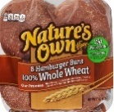  Hamburger Buns  Size: 15 oz  UPC: 072250003988  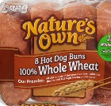  100% Whole Wheat Hotdog Buns  Size: 13 oz  UPC: 072250004862 | Arnold  100% Whole Wheat  Size: 24 oz  UPC: 073410013755  Country 100% Whole Wheat  Size: 24 oz  UPC: 073410013502  100% Whole Wheat Sandwich Thins  Size: 12 oz  UPC: 073410955758 |  | 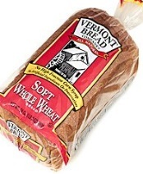  Vermont Bread Company  Soft Whole Wheat Bread  Size: 24 oz  UPC: 025911300018  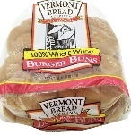  100% Whole Wheat Burger Buns  Size: 16 oz  UPC: 025911013307  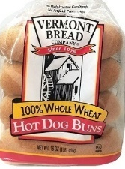  100% Whole Wheat Hot Dog Buns  Size: 16 oz  UPC: 025911013321
Sara Lee  100% Whole Wheat  Size: 20 oz  UPC: 72945601345 | Freihofer’s  100% Whole Wheat  Size: 24 oz  UPC: 071330601496 |  | 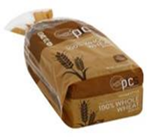  Pics by Price Chopper  Whole Wheat Bread  Size: 24 oz  UPC: 041735090362
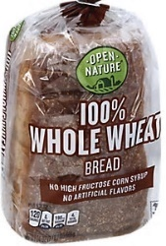  Open Nature  100% Whole Wheat  Size: 24 oz  UPC: 079893111544 | 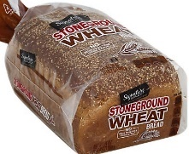  Signature Select  Stonegound Wheat  Size: 24 oz  UPC: 021130119745
Pepperidge Farms  Farmhouse 100% Whole Wheat  Size: 24 oz  UPC: 014100082774  Whole Grain 15 Grain Bread  Size: 24 oz  UPC: 014100085980 | Whole Grain 100% Whole Wheat  Size: 24 oz  UPC: 014100085997  Whole Grain German Dark Wheat  Size: 24 oz  UPC: 0141006962  100% Whole Wheat Hamburger Buns  Size: 14.5 oz  UPC: 014100087861 |  | Whole Grain Honey Wheat  Size: 24 oz  UPC: 014100085973  Whole Grain Oatmeal  Size: 24 oz  UPC: 014100088219  Whole Grain Soft Sprouted Grain  Size: 22 oz  UPC: 014100048565
Tortillas and Whole Wheat Pasta
New Items added:
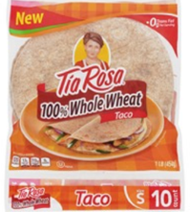  Tortillas  Tia Rosa  100% Whole Wheat Tortillas  Size: 16 oz  UPC: 703965068008 |  | 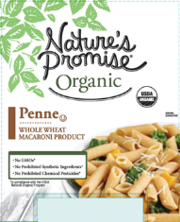  Whole Wheat Pasta  Nature’s Promise  Whole Wheat Penne  Size: 16 oz  UPC: 688267204302  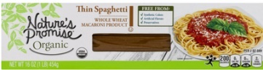  Whole Wheat Thin Spaghetti  Size: 16 oz  UPC: 688267204296

Helpful Resources Located on WIC Program Website - https://www.healthvermont.gov/family/wic
WIC Foods Guide

WIC Program and Shopping Guide

Download the Shopper App

WIC is here for you and we thank you for your patience during this challenging time.

