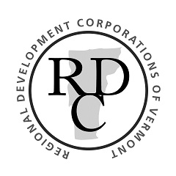
RESTART VERMONT TECHNICAL ASSISTANCE PROGRAM
Technical Assistance (TA) Provider FAQ

How can a business participate in the program as a technical assistance provider?
Any for-profit or non-profit technical assistance (TA) provider seeking to participate in the program should register at www.vermonteconomicdevelopment.com. Once the service provider’s registration and eligibility are confirmed, they will be added to the Technical Assistance Network registry.

How do I secure clients?
Contracts with clients in the program are not guaranteed. The registry will be available to both businesses and Recovery Navigators at each of the Regional Development Corporations (RDCs). A scope of work (SOW) will be executed after a client and Navigator select a technical assistance provider and a SOW is mutually agreed to by all three parties.

How will TA providers be paid?
TA providers must complete the project outlined in the SOW. Once the client business and Recovery Navigator confirm completion of the SOW, the TA provider will receive payment for services rendered from the ReVTA program’s fiscal agent.

Can TA providers work with more than one client?
Yes. TA providers may provide services to more than one business client at once as long as the provider has sufficient capacity.

Can a TA provider work with clients outside of the provider’s geographic area?
Yes. When providers register they will indicate which regions in Vermont they can serve.

What is the timeline for this project?
The program closes December 4, 2020. This means the SOW must be executed before this time and final documentation received by the fiscal agent, in order for payment to be issued.

Is TA provider information publicly available?
Only the company name, address, and value of the assistance provided will be public. Other information collected will be used only in the aggregate to report program results to the Agency of Commerce and the Vermont Legislature.

Is the value of the technical assistance counted towards the “Duplication of Benefits” calculation?
No.

