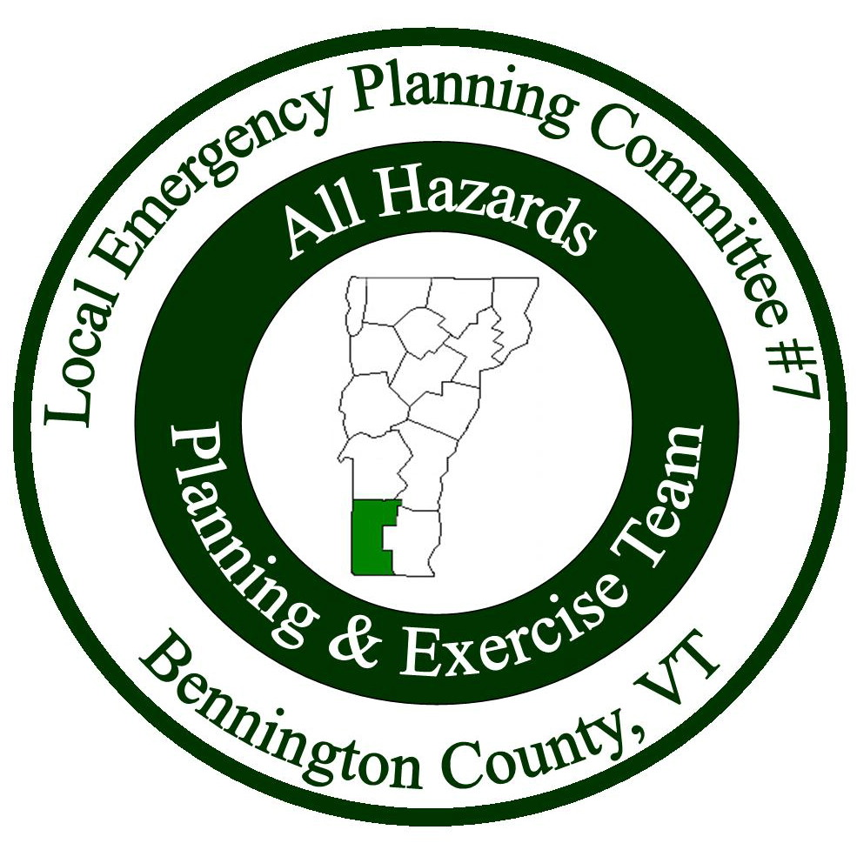

Meeting Minutes
Local Emergency Planning Committee (LEPC) District VII
Bennington County, Vermont
October 25, 2018 from 6:00 to 8:00PM
Bennington Project Independence
614 Harwood Hill Rd.
Bennington, VT 05201
______________________________________________________________

Attendees
Name | Affiliation
Kate Bryan | Battenkill Valley Health
John Gagnon | SWVT MRC
Nanci Gordon | Vermont 2-1-1
Amalio Jusino | Speaker
Bill Levine | Stamford EMD
Mike Meehan | Red Cross
Tom Mozzer | VT State Police
Dee Myrvang | VT Department of Health
Craig O’Dell | Pownal EMD
Dan Potvin | Stamford Selectman
Keith Squires | LEPC Chair/Arlington EMD
Allison Strohl | BCRC
Katie Vandale | Bennington Rescue
Dan Zimmer | LEPC Vice Chair, Fire Fighter Training Instructor

Introductions: Keith Squires started the meeting with introductions.

Meeting Minutes: Keith asked if there were any edits/comments about the meeting minutes. No one had any. Bill Levine made motion to accept the minutes, Kate Bryan seconded. All were in favor.

Treasurer’s Report: Keith went over the treasurer’s report – The report has not changed since the last meeting. The ending balance was $12,869.48. Dan Zimmer made motion to accept the treasurer’s report, Bill Levine seconded. All were in favor.

Presentation: Egos and Attitudes
Amalio Jusino discussed problems and gaps in the planning system. Stigmas and preconceived notions among first responders in different sectors. How different personalities can work together. Discussed how the different sectors can work together better by training together and not staying confined to their own sector during the training.

Discussion: Long-term Planning for Emergency Services
Keith started a discussion about how to plan for volunteer emergency service personnel in the coming years. Suggested possibly working with BCRC to bring in someone to develop a plan for the future. The group discussed recruiting and how to entice new volunteers. It was mentioned that even though the volunteer experience can be appealing, people have limited time these days. It’s a statewide issue.

Agency Reports:
Dan Zimmer, Fire Fighter Training Instructor: 2016 Emergency Response Guidebook is the most current version and everyone should be using that guide. Hazmat awareness is not a requirement for hazmat response. On March 23, there is a Hazardous Materials Operations Training at Bennington Fire Department. Bennington FD has a hazmat trailer that can be dispatched throughout the county. Operations training starts in January. NIMS has changed and has been rolling out new trainings.
Tom Mozzer, Vermont State Police: VSP has been visiting schools for threat assessment training.
Mike Meehan, Red Cross: Shelters have to be inspected and approved by the Red Cross in order to be considered a Red Cross shelter. If anyone has a shelter they want inspected call 800-660-9130. Send Mike an email if you aren’t sure if your shelter is approved. Red Cross can provide mass care for first responders by bringing food and drinks for responders while on scene. It will just take about an hour for them to arrive, so the responders need to be on scene for at least 3 hours for it to be necessary.
Allison Strohl: Read VEM notes from Rich Cogliano:

Here are some updates from VEM:

1) The next catastrophic exercise is scheduled for next fall. It will focus on the 72-96 hours post event and will setup commodities points of distribution.There is still opportunity to join if interested. Please contact Eric Forand at Eric.Forand@vermont.gov

2) The new Local Emergency Management Plan, LEMP, templates are on our website and I would encourage folks to get started filling those out. We will hold several workshops in the winter and spring to help fill those out and answer questions.

3) For schools, there is new school safety grant administrator at VEM, Sunni Eriksen. If school are interested in grants for safety planning, training, or exercising, please reach out to her at Sunni.Eriksen@vermont.gov

4) Finally, The VEM website has a new section geared toward local EMDs and EMCs. https://vem.vermont.gov/programs/emd This site contains information on documentation, EMD certification, and partners.

Adjourn: Meeting ended at 8:00PM.

Next Meeting: Thursday, January 24, 2019. Location TBD.

