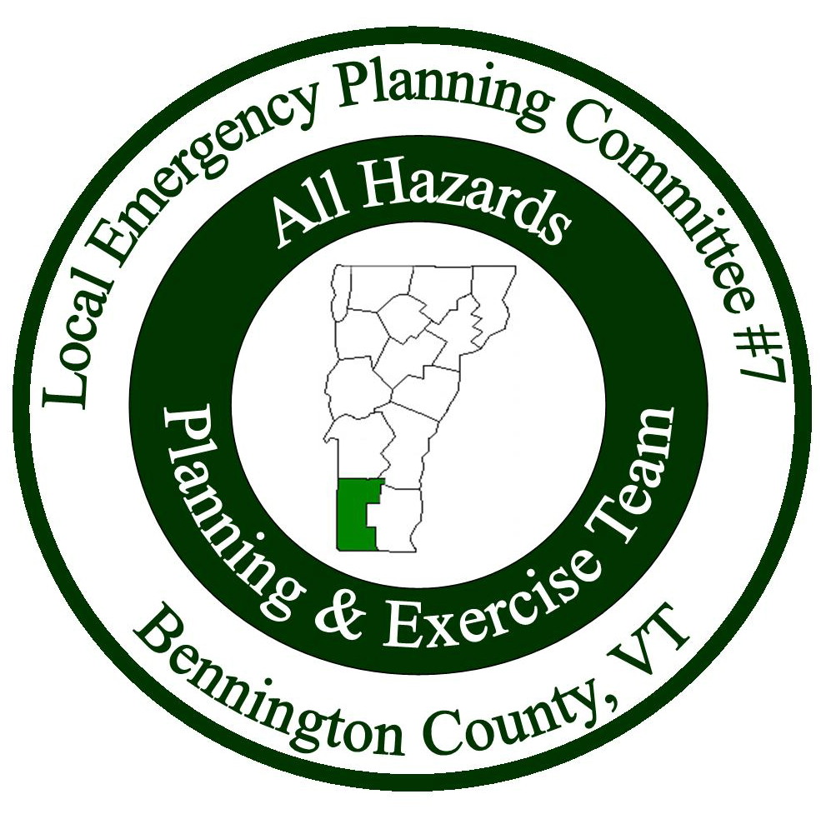

Meeting Minutes
Local Emergency Planning Committee (LEPC) District VII
Bennington County, Vermont
October 26, 2017 from 6:00 pm to 8:00 pm
Bennington Project Independence
614 Harwood Hill Rd.
Bennington, VT 05201
______________________________________________________________

Attendees
Name | Affiliation
John Gagnon | Bennington
Sheila Lawrence | Stamford
Bill Levine | Stamford EMD/Fire
Bruce Lierman | Bennington
Geoffrey Mazanec | SVMC
Michael Meehan | Red Cross
Thomas Mozzer | Vermont State Police
Dee Myrvana | VT DOH
Todd Sears | VEM
Keith Squires | LEPC Chair/Arlington EMD/Selectboard
Allison Strohl | BCRC
Dan Zimmer | Bennington County Mutual Aid

Introductions: Keith Squires started the meeting with introductions.

Meeting Minutes: Keith asked if there were any corrections or if anyone wanted to discuss the minutes. There were no comments. Dan Zimmer made a motion to accept the minutes, Sheila Lawrence seconded. All were in favor.

Treasurer’s Report: Keith talked about the treasurer’s report and mentioned that it is the same as last meetings report because the invoice was not received for last meetings meal. The balance is still $16,459.48. A motion was made to accept the treasurer’s report by Bill Levine, Sheila seconded. All were in favor.

Keith asked for a motion to be made to pay for the meal for this evenings meeting. The LEPC will be receiving an invoice for $130. Dan Zimmer made a motion to pay the invoice, Thomas Mozzer seconded. All were in favor.

Presentations: Todd Sears began his presentation on cyber security.
At the end of the presentation, John Gagnon asked what’s happening at the military level with Russian hacks? Todd said there is a lot happening at the federal level but he cannot speak to it, but he feels confident that the US is on top of everything cyber related even though there is not a lot of information available in the media.
Someone asked if DHS is represented within the state? Todd answered that customs and borders is represented here. There is no one in Vermont doing cyber related work but there is a regional person (region 1) who works for DHS.

DEMHS Report:
Todd relayed a message from the Hazard Mitigation Officer: the June/July flooding has created mitigation funding opportunities that will be available in March, reach out to Allison Strohl if your municipality would like help applying.

There is a new EMD two-hour seminar for those who have not been EMDs before. It will be offered in Bennington sometime in the coming months. VEM is running the full course in Addison tomorrow (October 27). The first official training will be held in November, then in February in Royalton.

VEM has been redesigning the LEOP template. There will be a draft ready in January that will be sent out for comments, then in mid to late February, the final draft will be available. 2019 will be the first year it’s used.

The annual Emergency Preparedness Conference was held in September. Next years conference will be held in September again. If anyone has any suggestions or comments about the conference, you can pass them onto Allison and she can pass them on to VEM. (The conference is free to attend and is typically held on a Friday and Saturday so that all emergency personnel, volunteer or paid, may attend)

Agency Reports:
VSP: There will be three additional troopers starting in late January and will be ready for duty in March.

Stamford: Received a grant for new generator for the school/town office/emergency shelter that is now installed and functions much better than the previous one.

Red Cross: Mike Meehan is the new representative for the Red Cross.
Recently they closed all offices except the Burlington office.
The number to call if the Red Cross is needed: 800-660-9130. This number goes to the 24/7 answering service.
If there is a fire event that lasts more than 3 or 4 hours, call the Red Cross. They will come out with food and drinks for the fire fighters.
There is a new Red Cross card that is given to the victim/clients that can be activated on scene.
If people are available for two weeks, Red Cross volunteers can go to any disaster they choose and can work in a variety of areas from client services to nursing to technical services.
Sound the Alarm is a program with the Red Cross that partners with fire departments and will install smoke detectors for free. If fire alarms are more than 10 years old, throw them out. The new alarms are permanent. Keith asked if they have gone into schools, Mike said no but they have gone through neighborhoods and left door hangers with information. John Gagnon said it was done at Mount Anthony two years ago.
There is a program manager position available with the Red Cross if anyone is interested, contact Mike for more information.
Mike Meehan’s contact information: Cell: 352-467-1486, Email: brvfd51@gmail.com

Dan Zimmer: focusing on firefighter needs in Bennington County and just did a training at Bennington Rural.
If there is a need for fire fighter awareness, contact Dan Zimmer.
There is a FF1 training in Manchester coming up.
The annual Fire Grant is in process.
Arlington FD has followed up on an issue to have their staff certified for flagger training and traffic incident management. Mike Meehan mentioned a traffic incident management he was familiar with and was wondering if the program Dan was mentioning was the national training, and Dan said yes it was. Bill asked if that program is going to be available to all departments. Dan said yes and that departments can register online. Keith said that departments should talk with their insurance company because that can be an incentive to hold the training. There may also be grant money available. Dan mentioned that you have to be a part of the VT Cities of Leagues and Towns to get the flagger training.

Adjourn: Meeting ended at 8:00 pm

Next Meeting: Thursday, January 25th. Location TBD.

