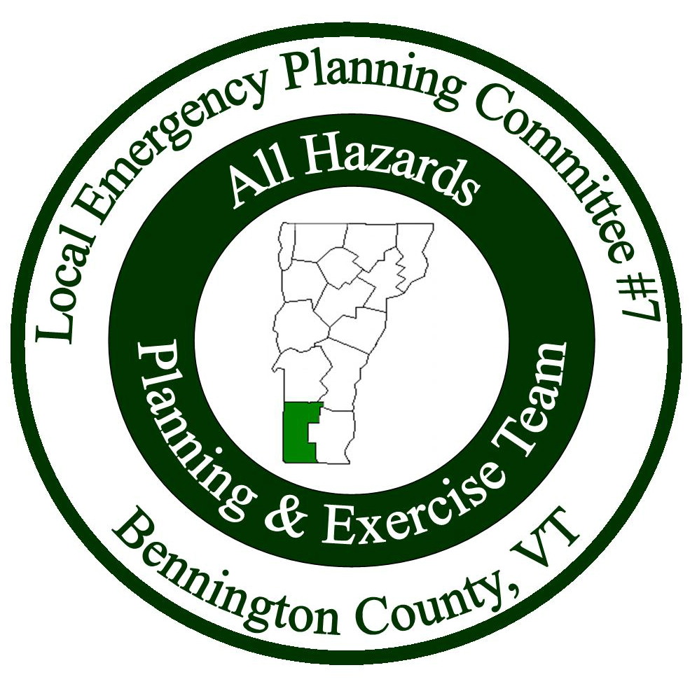

Meeting Minutes
Local Emergency Planning Committee (LEPC) District VII
Bennington County, Vermont
July 26, 2018 from 6:00 to 8:00PM
Bennington Project Independence
614 Harwood Hill Rd.
Bennington, VT 05201
______________________________________________________________

Attendees
Name | Affiliation
Kate Bryan | Battenkill Valley Health
Todd Cosgrove | SERC Chair
Natalie Elvidge | VT Homeland Security
John Gagnon | SWVT MRC
Nanci Gordon | Vermont 2-1-1
Sheila Lawrence | Stamford
Bill Levine | Stamford EMD
Dee Myrvang | VT Department of Health
Keith Squires | LEPC Chair/Arlington EMD
Allison Strohl | BCRC
Dan Zimmer | Fire Fighter Training Instructor
Robert Zink | VT State Police

Introductions: Keith Squires started the meeting with introductions.

Meeting Minutes: Keith asked if there were any edits/comments about the meeting minutes. No one had any. Dan Zimmer made motion to accept the minutes, Kate Bryan seconded. All were in favor.

Treasurer’s Report: Keith went over the treasurer’s report – In May, $3,200 was paid to the BCRC for the agreement. The ending balance was $12,869.48. Bill Levine made motion to accept the treasurer’s report, Sheila Lawrence seconded. All were in favor.

Presentations:

Todd Cosgrove, SERC Chair, LEPC Updates
Discussion points (for more information about any of the below points, contact Todd directly):
- Can notify Todd of EHS facilities that are not attending meetings so he can send a reminder that they should be at the meetings.
- LEPCs were concerned about liability issues, there should be no extra liability needed beyond what emergency responders have currently everyday.
- Should have EHS facilities give presentations on their emergency plans, for awareness, not for LEPC input.
- SERC/Hazchem Grant – Realized that the SERC wasn’t following the grant policy (that’s the reason for all the recent changes). LEPCs can apply for the $4000, any extra funds would be a separate grant process.
- Most LEPCs were awarded the funds they asked for, a couple LEPCs were turned down due to incomplete information.
- LEPC 2 submitted a letter that they were going to disband the LEPC. They are putting their resignation on hold for 90 days. They were mostly concerned about the liability issues.
- Projects for the Hazchem Grant – be specific on projects and what you are trying to accomplish.
- New requirement: LEPCs have to spend the grant money in 18 months with the new requirements.
- Keith said part of the reason LEPC 7 hasn’t applied for the money is that drills aren’t allowed anymore. Todd mentioned to write a letter to VEM Director, Erica Bornemann, know about this because VEM makes the exercise requirements.
- Allison asked what other RPCs are doing with the money. Todd replied that they are spending money on meals, inviting EHS companies to come and present plans, trainings, bringing in an exercise person for trainings, planning, and exercising.
- Nanci Gordon said that she participated in an exercise in Rutland a few years back where they exercised how the emergency information got out to the public, and how people in the neighborhood were going to be notified.
- Todd mentioned that it was a great idea to test the other responders and people involved in emergencies.
- Dee Myrvang said that she was resistant to tabletops in the beginning also, but now sees the value in getting everyone together to discuss what would happen.
- Dee also mentioned that it is helpful to explain to businesses how you are there to help/assist and explain what you can provide by doing the tabletop.
- Keith asked about VEM presence at LEPC meetings and Allison explained that they are no longer being asked to participate or attend LEPC meetings. Todd said it would also be good to write Erica, VEM Director, about VEM presence at the meeting being missed and why.
- Todd mentioned that some LEPCs think they have to meet every month but quarterly works well, as long as the LEPCs meet the state and federal goals and requirements.
- Keith asked if there is a chain of command the LEPC should be following and asked if Todd could send a list. Todd said he would.
- Todd briefly discusses Tier II reports and mentioned that they have been increasing the submittal amount by several thousand. But if we see any that are missing from the EHS list, let Todd know so he can get them to submit.

- On a separate note: The Division of Fire Safety is doing a program to help dispose of PFOA foam. If any fired department has foam from 2002 or prior, it probably contains PFOA. It is in fire departments, apparatus, and in tank trucks. The Fire Academy is a point of contact to report the quantities, ANR is also. The flyer is attached to the end of these minutes.

Natalie Elvidge, VT Homeland Security Unit Updates
- As of 2017, VEM and Homeland Security have been separated. There have also been personnel changes at HSU (Natalie will send me the updates to distribute to the LEPC).
- HSU gets a lot less funding these days.
- HSUs goal is to develop relationships with groups around the state and to notify them of funding
- Their grant money is intended to be seed money but not intended to be long term project funding.
- Gap analysis helps them determine how much money to spend.
- 3.9 million was received in 2018.
- After the budget is determined, applications will go out and people can apply.
- HSU then submits to FEMA showing where the federal money was spent.
- Have a month and a half to get the federal money out the door, so decisions are made quickly.
- Legacy projects include: VEM and VIC (for staff, training, travel, support, etc.)
- Always looking at the needs of the state.
- 2019 – School safety will be a place where the money is spent.
- 2018 – Cyber security was where the money was spent.
- Applications are always due at the end of Feb. A notice will come out in the beginning of January.
- Keith asked if the LEPC wanted to apply for a grant, could they call and talk to someone to see if they are eligible before doing the application? Natalie said yes, and that she would be the point of contact and would be happy to answer any questions.
- Dee asked is schools could apply directly for funding – Natalie said that $4 million was for schools to apply for security updates last year, and $1 million went to a new school safety initiative, which should happen in the next couple months, for school safety and training.

Agency Reports:
Nanci Gordon, VT 2-1-1: They recently updated the website, and you can now text 2-1-1.
Dan Zimmer: Is going to be the managing instructor of Fire Fighter 1 and 2 in Bennington, that will start the first week of September and end in June. The Bennington FD applied for it and received it. Keith said it has come up that people want to volunteer but can’t because they don’t have the formal training. Dan said the department should look at what they can do, and there is now a national fire fighter program for Basic External Fire Fighter training, but VT elected to keep the full set of requirements.

Bill Levine, Stamford: Discussed the EMD certificate and Vermont EM Conference – Allison said she will send out the EM Conference email with the minutes.

Keith asked Allison if she could contact Rich for any VEM updates. Allison said she would.

Adjourn: Meeting ended at 8:00PM.

Next Meeting: Thursday, October 25, 2018. Location TBD.

Department of Public Safety Department of Environmental
Division of Fire Safety Conservation
Waste Management and Prevention Division

Date: July 19, 2018

The Vermont DEC Waste Management & Prevention Division and the Vermont DPS Division of Fire Safety are partnering on funding an effort to collect and dispose of potentially hazardous firefighting foams that are currently stored at local fire departments throughout the State.

The state is concerned about the public health and environmental impacts of “legacy” (pre 2002) Type B Aqueous Film Forming Foam (AFFF). All AFFF uses “fluorinated surfactants” as an ingredient to reduce chemical surface tension and cover flammable liquid fires. These fluorinated surfactants exist as different lengths of carbon chains. The longer the chain, the more resistant to breaking down in nature, more likely to contaminate drinking water and soil, be accumulated in living organisms, and cause health effects. Modern AFFF uses more structurally complex chains and are not known to pose as significant a threat to public health and the environment.

The final details of the collection program have not yet been finalized. Our plan is to set up five drop off spots throughout the state and have a period of time when fire departments can drop off any containers of pre 2002 foam. A contractor for the state will collect the foam for disposal through incineration. Once the details are finalized the state will send out another announcement.

If you have any questions about this program, please contact Michael Nahmias at 802-522-4595 or by email: michael.nahmias@vermont.gov.

