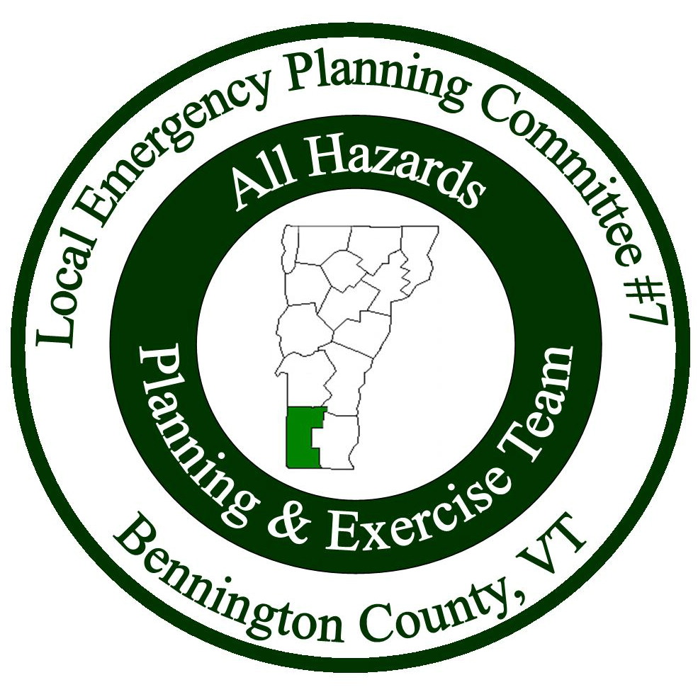

Meeting Minutes
Local Emergency Planning Committee (LEPC) District VII
Bennington County, Vermont
April 26, 2018 from 6:00 to 8:30PM
Bennington Project Independence
614 Harwood Hill Rd.
Bennington, VT 05201
______________________________________________________________

Attendees
Name | Affiliation
James Downes | NE HIDTA (speaker)
Nick Grimes | Vermont State Police
James Gulley | Manchester Police (speaker)
Mike Hall | Manchester Police
Bob Mattison | Manchester Police
Michael Meehan | Red Cross Coordinator
Dare Meunier | ACT
Maryann Morris | The Collaborative
Thomas Mozzer | Vermont State Police
Craig O’Dell | Pownal EMD
Keith Squires | LEPC Chair/Arlington EMD
Allison Strohl | BCRC
Stephanie Thompson | NE HIDTA (speaker)

Introductions: Keith Squires started the meeting with introductions.

Meeting Minutes: Keith asked if there were any edits/comments about the meeting minutes. No one had any. Mike Hall made motion to accept the minutes, Craig O’Dell seconded. All were in favor.

Treasurer’s Report: Keith went over the treasurer’s report – in November, $260 was spent for the two previous meetings, and in March, $130 was spent for the January meeting that was cancelled. The ending balance was $16,069.48. Mike Hall made motion to accept the treasurer’s report, Bob Mattison seconded. All were in favor.

Presentations:
James Downes, New England High Intensity Drug Trafficking Area
- HIDTA (High Intensity Drug Trafficking Areas) was developed to create a drug control strategy.
- 64 million prescriptions of gabapentin this year (a lot less the previous year), for anxiety and seizers, has the potential for abuse, these are the things HIDTA looks for, as well as talking to people in the field, looking at reports, etc.
- Cocaine and crack cocaine will be/are on the rise.
- Synthetic opioids are being seen on a regular occasion. Synthetic ingredients are showing up in marijuana that can cause seizures and internal bleeding.
- Craig asked if they’ve seen a reduction in any drugs – James said that they are making headway with prescription drug use and heroin (looking at overdose reports).
- Mike Meehan asked about cartels – James said it is definitely moving across the country and they are looking at how marijuana is moving into and out of states that have legalized and not legalized its use.
- Maryann Morris said THC levels have drastically increased since the 60’s, so it’s not the same product.
- Mike Meehan asked if they are doing outreach to fire departments – James said they have not and that the safety aspect should be delivered by the hazmat team.
- Stephanie Thompson said that they do have materials regarding fentanyl for first responders.

James Gulley, Manchester Police Department, CDC Law Enforcement Teacher
- Keith asked about traffic routes, James said that there are all sorts of popular corridors and that drug traffickers know when to make their way through certain areas.
- Adverse Childhood Experiences (ACES), they (law enforcement) are asking what happened to these people as children. A score a 5 or more on the ACES means they could be at higher risk for substance abuse and other serious problems.
- Those who score high on the ACES test typically have addictive personalities.
- Tom Mozzer mentioned that every heroin arrest he’s seen, the person started with prescriptions.
- Prevention is the key.
- Trying to make ACES a common practice to identify children that may be more at risk so they have the resources/support they need.

Stephanie Thompson, New England High Intensity Drug Trafficking Area
- 2.1 million people have opioid use disorder.
- More males than females, and the main age group is 39-42 years old.
- Of all New England states, Vermont has the least amount of overdose deaths.
- Those in treatment are increasing and those on the waiting list are decreasing.
- Law Enforcement, Prevention, Treatment, Recovery are the four pillars.
- Employment is a big part of recovery, getting people back in jobs and helping them with resumes helps significantly.
- Those who are testing positive are not being booted from programs. It should not be seen as a failure but as a set back.
- Governor’s Opioid Coordination Council (more information in attached document).

LEPC-BCRC Agreement: Keith talked about the BCRC-LEPC agreement – the cost will be $3,200 for services for 2018. Mike Hall made motion to accept the agreement, Mike Meehan seconded. All were in favor.

Adjourn: Meeting ended at 8:30PM.
Next Meeting: Thursday, July 26, 2018. Location TBD.

